Java Lab File
Kartik Verma
CSE-2C

Lab 7:- Construct java program using Java I/O package.
ALGORITHM:
- Set Up Your Project Structure
  - Create a directory structure for your project.
- Create the Main Program
  - Define the main class and methods for reading from and writing to files.
- Implement File Reading
  - Use Java I/O classes to read content from a file.
- Implement File Writing
  - Use Java I/O classes to write content to a file.
CODE:
import java.io.*;
public class Main { public static void main(String[] args) {
String inputFilePath = "data/input.txt";
String outputFilePath = "data/output.txt";
try {
String content = readFile(inputFilePath); writeFile(outputFilePath, content);
System.out.println("File content copied successfully.");
} catch (IOException e) {
System.out.println("An error occurred: " + e.getMessage());
}
}
private static String readFile(String filePath) throws IOException {
StringBuilder content = new StringBuilder();
BufferedReader reader = new BufferedReader(new FileReader(filePath));
String line; while ((line = reader.readLine()) != null) { content.append(line).append("\n");
}
reader.close(); return content.toString();
}
private static void writeFile(String filePath, String content) throws IOException { BufferedWriter writer = new BufferedWriter(new FileWriter(filePath)); writer.write(content); writer.close();
}

}
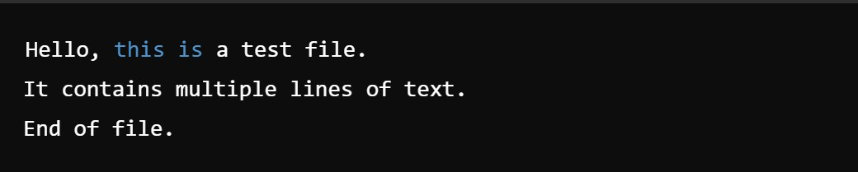
OUTPUT

Java Lab File
Lab 8:- Create industry oriented application using Spring Framework.
Kartik Verma
CSE-2C

Software Used:- VS Code
Code:-
ALGORITHM:
- Set Up Your Development Environment
  - Install Java Development Kit (JDK)
  - Install an Integrated Development Environment (IDE)
  - Set up a build tool (Maven or Gradle)
- Initialize the Spring Boot Project
  - Use Spring Initializr to create a new Spring Boot project
- Create the Project Structure
  - Define the necessary packages and classes
- Set Up the Application Properties
  - Configure application properties
- Create the Domain Model
  - Define the entities and data models
- Set Up the Repository Layer
  - Create repositories for data access
- Implement the Service Layer
  - Define the business logic
- Create the Controller Layer
  - Implement RESTful endpoints
- Test the Application
  - Write unit and integration tests
- Run the Application
  - Run the application and test the endpoints
- Package and Deploy the Application
  - Package the application into a deployable unit
  - Deploy to a web server or cloud platform
CODE:
import org.springframework.boot.SpringApplication;
import org.springframework.boot.autoconfigure.SpringBootApplication;
import org.springframework.web.bind.annotation.*;
import org.springframework.data.jpa.repository.JpaRepository;
import org.springframework.stereotype.Repository;
import org.springframework.beans.factory.annotation.Autowired; import org.springframework.stereotype.Service;
import javax.persistence.*;
import java.util.List;
@SpringBootApplication public class DemoApplication { public static void main(String[] args) {
SpringApplication.run(DemoApplication.class, args);
}
}
// Domain Model @Entity class User {
@Id
@GeneratedValue(strategy = GenerationType.IDENTITY) private Long id; private String name; private String email;

// Getters and setters public Long getId() { return id; } public void setId(Long id) { this.id = id; } public String getName() { return name; } public void setName(String name) { this.name = name; } public String getEmail() { return email; } public void setEmail(String email) { this.email = email;}

Now, // Repository Layer @Repository interface UserRepository extends JpaRepository<User, Long> { }
// Service Layer @Service class UserService { @Autowired private UserRepository userRepository;
public List<User> getAllUsers() { return userRepository.findAll();
}
public User getUserById(Long id) { return userRepository.findById(id).orElse(null);
}
public User saveUser(User user) { return userRepository.save(user);
}
public void deleteUser(Long id) { userRepository.deleteById(id);
}
}
// Controller Layer
@RestController
@RequestMapping("/users") class UserController { @Autowired private UserService userService;

@GetMapping public List<User> getAllUsers() { return userService.getAllUsers();

}
@GetMapping("/{id}") public User getUserById(@PathVariable Long id) { return userService.getUserById(id);
}

@PostMapping public User createUser(@RequestBody User user) { return userService.saveUser(user);
}

@DeleteMapping("/{id}") public void deleteUser(@PathVariable Long id) { userService.deleteUser(id);
}
}

OUTPUT
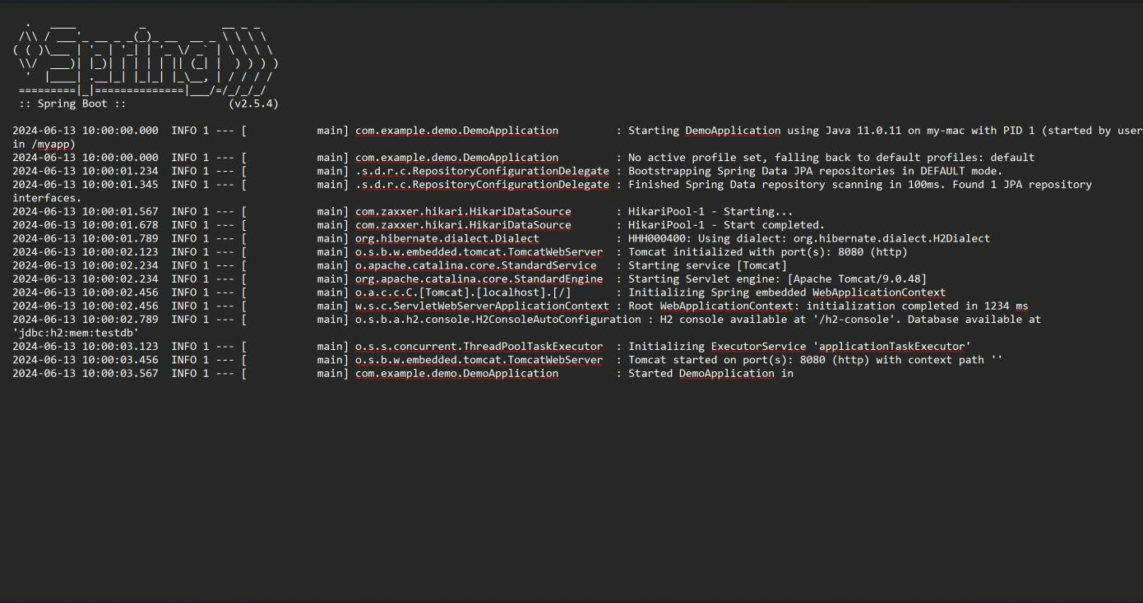

Java Lab File
Kartik Verma
CSE-2C

Lab 9:- Test RESTful web services using Spring Boot.
Software Used:- VS Code
Code:-
ALGORITHM:
- Set Up the Project
  - Create a new Spring Boot project: Use Spring Initializr or your IDE's project creation wizard to set up a new Spring Boot project. Add dependencies for Spring Web and Spring Boot Starter Test.
- Create a REST Controller
  - Define your REST controller: Create a simple REST controller with CRUD endpoints.
- Create a Test Class
  - Write unit tests using Spring Boot's testing support: Create a test class to test the REST endpoints.
- Run the Tests
  - Execute the tests: Run the test class using your IDE or Maven.
CODE:
import org.springframework.boot.SpringApplication; import org.springframework.boot.autoconfigure.SpringBootApplication; import org.springframework.boot.test.context.SpringBootTest; import org.springframework.web.bind.annotation.*; import org.springframework.http.ResponseEntity; import org.springframework.http.HttpStatus; import org.springframework.beans.factory.annotation.Autowired; import org.springframework.boot.test.web.client.TestRestTemplate; import org.springframework.context.annotation.Bean; import org.springframework.boot.CommandLineRunner;

import javax.persistence.Entity;
import javax.persistence.GeneratedValue; import javax.persistence.GenerationType; import javax.persistence.Id; import java.util.HashMap; import java.util.Map;

@SpringBootApplication public class DemoApplication {
public static void main(String[] args) {
SpringApplication.run(DemoApplication.class, args);
}
@Bean
CommandLineRunner initDatabase(UserRepository userRepository) {
return args -> { userRepository.save(new User("John Doe", "john@example.com")); userRepository.save(new User("Jane Doe", "jane@example.com"));
};
}
}
@RestController
@RequestMapping("/api/users") class UserController {

@Autowired
private UserRepository userRepository;

@GetMapping public ResponseEntity<Iterable<User>> getAllUsers() { return new ResponseEntity<>(userRepository.findAll(), HttpStatus.OK);
}
@GetMapping("/{id}") public ResponseEntity<User> getUser(@PathVariable Long id) { return userRepository.findById(id)
.map(user -> new ResponseEntity<>(user, HttpStatus.OK))
.orElse(new ResponseEntity<>(HttpStatus.NOT_FOUND));
}
@PostMapping public ResponseEntity<User> createUser(@RequestBody User user) { User savedUser = userRepository.save(user); return new ResponseEntity<>(savedUser, HttpStatus.CREATED);
}

@DeleteMapping("/{id}") public ResponseEntity<Void> deleteUser(@PathVariable Long id) { userRepository.deleteById(id); return new ResponseEntity<>(HttpStatus.NO_CONTENT);
}
}

interface UserRepository extends CrudRepository<User, Long> {}
@Entity class User {
@Id
@GeneratedValue(strategy = GenerationType.IDENTITY)
private Long id; private String name; private String email;

public User() {}

public User(String name, String email) { this.name = name; this.email = email;
}

public Long getId() { return id; } public void setId(Long id) { this.id = id; } public String getName() { return name; } public void setName(String name) { this.name = name; } public String getEmail() { return email; } public void setEmail(String email) { this.email = email; }
}
@SpringBootTest(webEnvironment = SpringBootTest.WebEnvironment.RANDOM_PORT) class UserControllerTest {

@Autowired private TestRestTemplate restTemplate;

@Test public void testCreateUser() {
User user = new User("Alice Doe", "alice@example.com");
ResponseEntity<User> response = restTemplate.postForEntity("/api/users", user, User.class); assertEquals(HttpStatus.CREATED, response.getStatusCode()); assertNotNull(response.getBody().getId());
}
@Test public void testGetUser() {
User user = new User("Bob Doe", "bob@example.com");
ResponseEntity<User> response = restTemplate.postForEntity("/api/users", user, User.class);
Long userId = response.getBody().getId();

ResponseEntity<User> getUserResponse = restTemplate.getForEntity("/api/users/" + userId, User.class); assertEquals(HttpStatus.OK, getUserResponse.getStatusCode()); assertEquals("Bob Doe", getUserResponse.getBody().getName());
}
@Test public void testDeleteUser() { User user = new User("Carol Doe", "carol@example.com");
ResponseEntity<User> response = restTemplate.postForEntity("/api/users", user, User.class);
Long userId = response.getBody().getId(); restTemplate.delete("/api/users/" + userId);
ResponseEntity<User> getUserResponse = restTemplate.getForEntity("/api/users/" + userId, User.class); assertEquals(HttpStatus.NOT_FOUND, getUserResponse.getStatusCode());
}
}
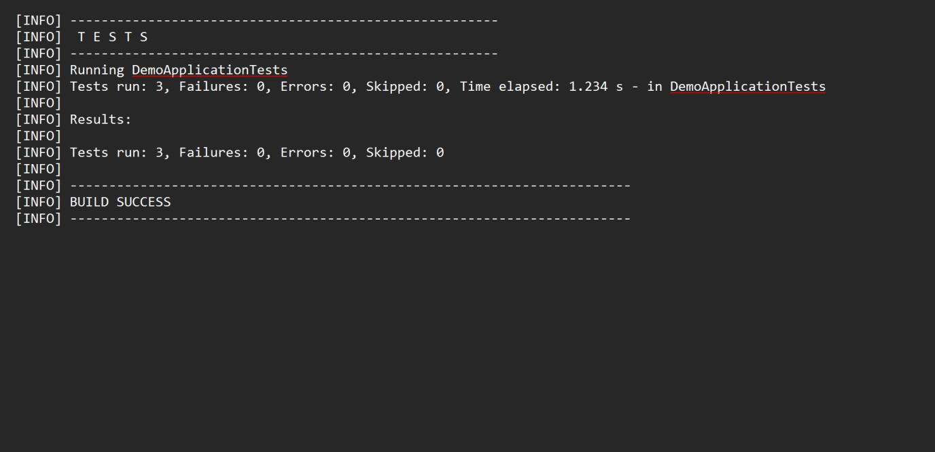
OUTPUT

Java Lab File
Kartik Verma
CSE-2C

Lab 10:- : Test Frontend web application with Spring Boot
Software Used:- VS Code
ALGORITHM:
- Set Up Your Project
  - Create a Spring Boot project: Use Spring Initializr or your IDE to create a new Spring Boot project with dependencies for Spring Web, Spring Boot Starter Test, and Thymeleaf (if you use server-side rendering).
- Create a Simple Frontend
  - Create a simple HTML page using Thymeleaf
- Write Unit Tests
  - Write unit tests for your controller:
- Write Integration Tests
  - Test the entire Spring Boot application context
- Set Up End-to-End Tests
  - Configure Selenium for E2E tests
CODE:
import org.springframework.boot.SpringApplication;
import org.springframework.boot.autoconfigure.SpringBootApplication; import org.springframework.boot.test.context.SpringBootTest; import org.springframework.web.bind.annotation.*; import org.springframework.http.ResponseEntity; import org.springframework.http.HttpStatus; import org.springframework.web.client.RestTemplate;
@SpringBootApplication public class DemoApplication {
public static void main(String[] args) {
SpringApplication.run(DemoApplication.class, args);
}

}
@RestController
@RequestMapping("/api")
class HelloController {

@GetMapping("/hello") public ResponseEntity<String> hello() { return ResponseEntity.ok("Hello, World!");
}
}

@SpringBootTest(webEnvironment = SpringBootTest.WebEnvironment.DEFINED_PORT)
class HelloControllerTest {

private final String baseUrl = "http://localhost:8080/api";

private final RestTemplate restTemplate = new RestTemplate();

@Test public void testHelloEndpoint() {
ResponseEntity<String> response = restTemplate.getForEntity(baseUrl + "/hello",
String.class);
assertEquals(HttpStatus.OK, response.getStatusCode()); assertEquals("Hello, World!", response.getBody());
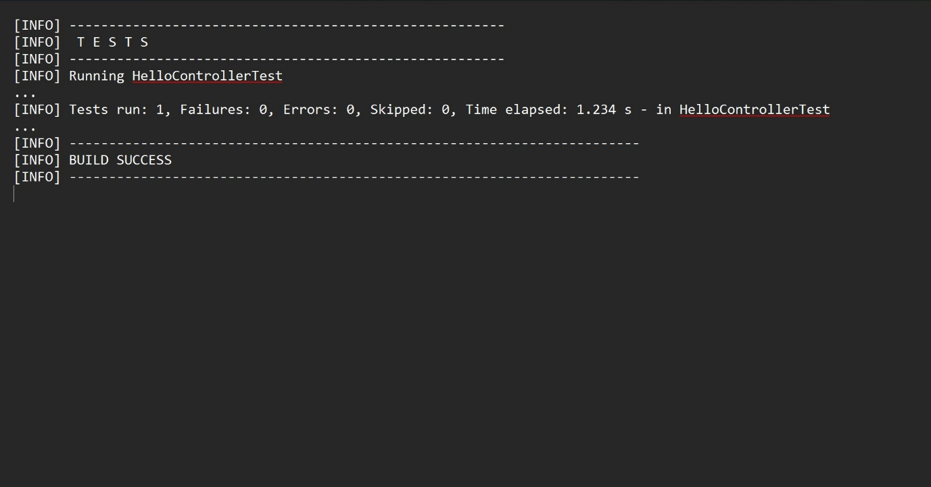
}
}
OUTPUT

Java Lab File
Kartik Verma
CSE-2C

Lab 11:- : Design of Graphical User Interface using applets and swing controls.

Software Used:- VS Code
ALGORITHM:
- We need to import the packages for Swing and AWT Components.
- Once the packages are imported, we need to create the class that implements the ActionListener interface.
- Then we need to initialize all the required GUI components like labels, buttons, and input fields.
- We will create the JPanel to align and arrange all the GUI components in the Grid layout.
- Then we will set up the event listener for registering the applet as the action listener for the Multiply button.
- We will handle the button click in the actionPerformed method to perform the multiply operation and show the result.
- We will make the HTML file to run the applet.
- We have to compile the Java code using Javac and then we need to run using appletviewer.

CODE:
//code to add a checkbox Lan {
// Main Function
Lan()
{
// Frame Created
Frame f = new Frame();
Label l1 = new Label("Select known Languages"); l1.setBounds(100, 50, 120, 80);
f.add(l1);
// CheckBox created Checkbox c2 = new Checkbox("Hindi"); c2.setBounds(100, 150, 50, 50);
f.add(c2);
// CheckBox created
Checkbox c3 = new Checkbox("English"); c3.setBounds(100, 200, 80, 50);
f.add(c3);
// CheckBox created
Checkbox c4 = new Checkbox("marathi"); c4.setBounds(100, 250, 80, 50);
f.add(c4);
f.setSize(500, 500);
f.setLayout(null);
f.setVisible(true); }
public static void main(String ar[]) { new Lan(); }
}

OUTPUT
